ROBOMANIPAL
(Edge AI)

EDGE AI
Edge AI is deployment /processing data and AI algorithms on local nearby devices rather than processing it on Cloud computing. Once the model is made it goes under series of steps like training and testing for getting higher efficiency and accuracy .these model use extensive data processing that require large computational power which is done by using Cloud computing where all hardware resources are there for the work to be done .
But in Edge AI we generally use the nearby resources rather than depending solely on the cloud computing .these resources include mobile laptops and microcontrollers and microprocessors. Helps deliver local storage ,compute and network services.
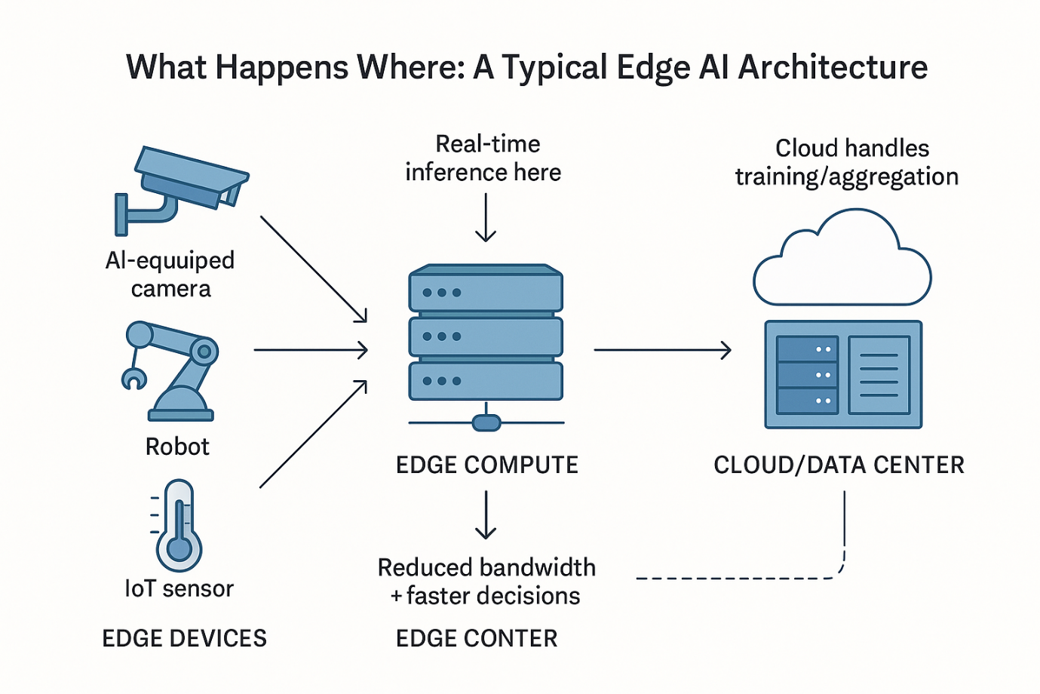

Edge AI Building Blocks
- Data ingestion-It is done using data endpoint with high velocity .it is process of obtaining all the data and importing it or storing it in databases.
- M2M Brokers-Edge AI uses brokers to run message and signals from machine to machine communication
- Object storage-all the unstructured data like that from video or mic is stored in it.
- Function as a service-it is used to run light weight computation
- No time series Database-more structured data goes into time series database and not in sequel database.
- Steam processing-it is a complex task of processing and performing real time queries and problem as it comes
- ML model

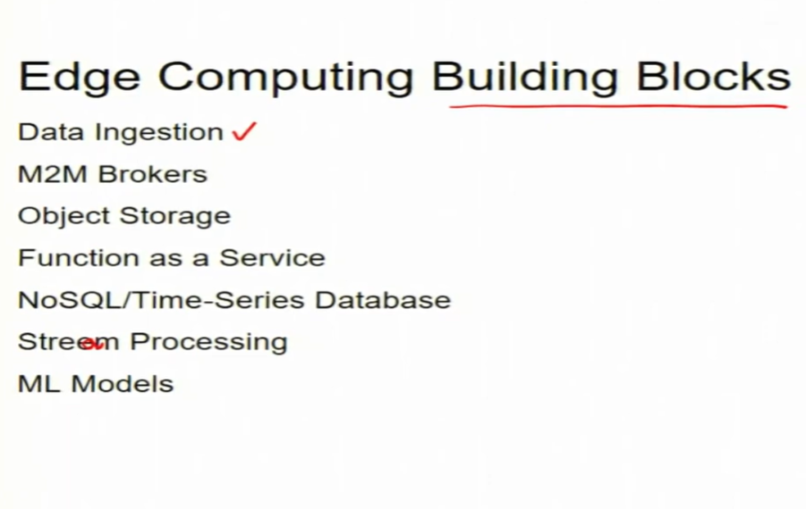

Application of Edge AI
- Autonomous vehicles and ADAS
- Smart surveillance and security systems
- Industrial automation and predictive maintenance
- Healthcare monitoring and medical devices
- Smart cities (traffic, parking, public safety)

Benefits of using Edge AI
- Lower Latency (Faster Decisions)
- Reduced Bandwidth & Costs
- Improved Privacy & Security
- Offline Capability / Reliability
- Scalability for IoT
- Energy Efficiency
- Privacy

Drawbacks of Edge AI
- High initial and hardware costs
- Low computing and storing capability
- Hard to expand

